Little Sparks Preschool
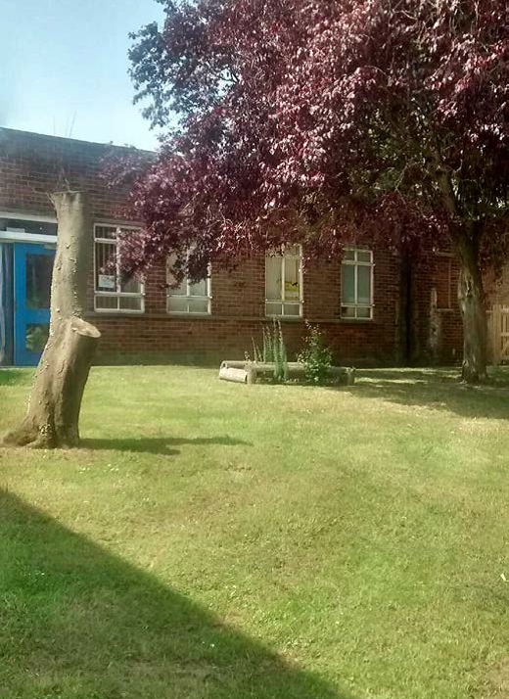

Little Sparks Preschool
Valley Primary
Knowland Grove
Norwich
NR5 8YB
Telephone: 01603 740677
Mobile: 07592 525542

Registered Charity Number: 1079011
Introduction

Little Sparks Preschool is a charitable organisation. We welcome the close involvement of parents and carers and run by a voluntary committee of parents. We are registered with OFSTED to provide early years education for 10 children aged 2 years old and 24 children aged 3 and 4 years old per session.

Aims

The aims of the preschool:

- Provide a safe place for children to learn to socialise and make friends
- For children to experience new activities and have a go
- Support the children’s growing independence in a safe, nurturing and learning environment.

What we do

We provide a learning environment for 2 year olds that is exciting and stimulating indoors and out.

We allocate every child a ‘key person’. The key person will work closely with your child and you to support your child during their time at Little Sparks.

We ensure all the children have equal access to a diverse and rich curriculum.

We follow each child’s interests and extend their play and learning.

How we are managed

Little Sparks is a registered charity with a committee of parents, carers and representatives of the local community who manage the group.

Committee meetings are held each term and all parents and carers of children who attend Little Sparks are eligible to join the committee. The committee is elected annually at an Annual General Meeting held in the autumn.

All committee members require DBS checks

Our committee officers are:

Chairperson Karen Rowley
Secretary Jackie Walker
Treasurer Karen Chapman

Our Staff

All childcare is provided by registered, professionals who are fully trained in looking after children and have been DBS checked.

Position | Name | Area of responsibility
Childcare Manager | Jackie Walker | DSL ENCO Prevent Duty
Deputy Childcare Manager | Donna Reynolds | DSL Health and Safety Behaviour Management Food Hygiene
Childcare Practitioner | Tammy Jay | DSL SENCO
Childcare Practitioner  Childcare Practitioner  Volunteer Practitioner | Laura Kelly  Chloe-Jane Herring  Karen Chapman | CP E-Safety First Aid Fire Safety  CP

Opening Times

Little Sparks is open Tuesday to Friday for 2 year olds. We are open for 47 weeks per year for funded and non-funded children. Funding is dependent on individual family criteria.

Tuesday 8:50 – 11:50 12:20 – 3:20
Wednesday 8:50 – 11:50 12:20 – 3:20
Thursday 8:50 – 11:50 12:20 – 3:20
Friday 8:50 – 11:50 12:20 – 3:20

Admission for funded children is the term after their second birthday.
Fee paying children once they turn 2.
.
Please make sure that you arrive a couple of minutes before the gate is open then all the children can start the session on time and that you are there at the end of the session.

Term dates

Autumn Term 3rd September to 19th December 2025

Spring Term 6^{h} January to 27th of March 2026

Summer Term 14th April to August 2026 date to be confirmed.
We follow Norfolk County Council School Calendar

Costs

Sessions are FREE for all funded children the term after their second birthday.
From September 2025 some children maybe eligible for 30 hours funding with the option of an extra 30 minutes at the end of the day, cost for this is £2.25 per session.
However, please make sure your children attend their allocated sessions – prolonged absence could mean funding being stopped. It also helps with the settling in and continuity for your child.

Fee Paying

Non funded sessions cost £13.50 per session.

You will be invoiced fees at the beginning of the month which can be paid directly into the bank. In the event of absence, illness or holidays fees will still be charged.

At the end of any fortnightly period of absence or non-payment we reserve the right to reallocate your child’s place if we are not notified of the reason and payment due paid in full.

Clothing

Please put children in clothing that you don’t mind getting messy and we ask that you bring a spare set of clothes, nappies, wipes, nappy bags, for your child which can be kept in a named bag, in case of any little accidents.

As they progress towards toilet training, please talk with your Key Person to enable us to work together. We encourage children to use the toilet independently so please dress them in clothing which supports this, ensure clothing is easy for children to pull down or undo when requiring the toilet (elasticated bottoms are easier)
If you wish us to use cream when changing nappies, please let a member of staff know.
Please label your child’s name on every item of clothing to help staff identify who it belongs to.

Children use a variety of equipment inside and outside, so please ensure that your child is appropriately dressed to allow them to be safe. Appropriate shoes for age and no long dresses, crop-tops, or strappy sun dresses are to be worn.

On sunny days we provide sun hats for your child, on wet days or when the ground is muddy please provide wellies to wear. We provide outdoor clothing and we spend a lot of time outdoors experiencing all weather conditions, if your child is well enough to attend then they will be encouraged to enjoy free flow play throughout the session.

Jewellery

To reduce the risk of accidents please limit the jewellery your child wears. No loose jewellery (necklaces, drop earrings) should be worn but stud earrings are acceptable

If using hair bobbles and hair clips, please be aware children may take them off and lose them.

Staff will not be responsible for hair clips, earrings or any item of jewellery if they are lost during a session.

Toys / Comforters

Bringing something from home, staff cannot accept responsibility if they get lost or broken, please limit the amount to one small item not the one they need for bed time to get to sleep. This must fit in their bag on their peg in the corridor.
Items left outside must not block the front door safety exits and are left at your own risk.

Home Visits

We will arrange a time for a home visit where time allows
Two staff members will pop in to meet you and your child. This also provides you with an opportunity to tell us about your child ask questions and discuss any concerns you may have, visits usually last around 45 minutes.

How we operate

We follow the Early Years Foundation Stage (EYFS)

Through observing your child, encouraging play and having fun we seek to extend and build your child’s knowledge and understanding. The Areas of Learning and Development consist of 3 Prime areas which are Personal, Social and Emotional Development, Physical Development and Communication and Language. There are 4 Specific Areas which are Literacy, Mathematics, Understanding the World and Expressive Arts and Design.
We value parental contribution and recognise the important part that families play in the education of their child.
We provide an environment in which all children are supported to reach their full potential. We follow the Department of Education and Skills Special Educational Needs New Code of Practice 2014. We work in partnership with parents and a range of agencies.

Settling in

Some children do not settle in quite as easily as others and may need a parent or carer to stay with them for a while to start with. Please feel free to do this and in time your child will be happy to stay on their own.

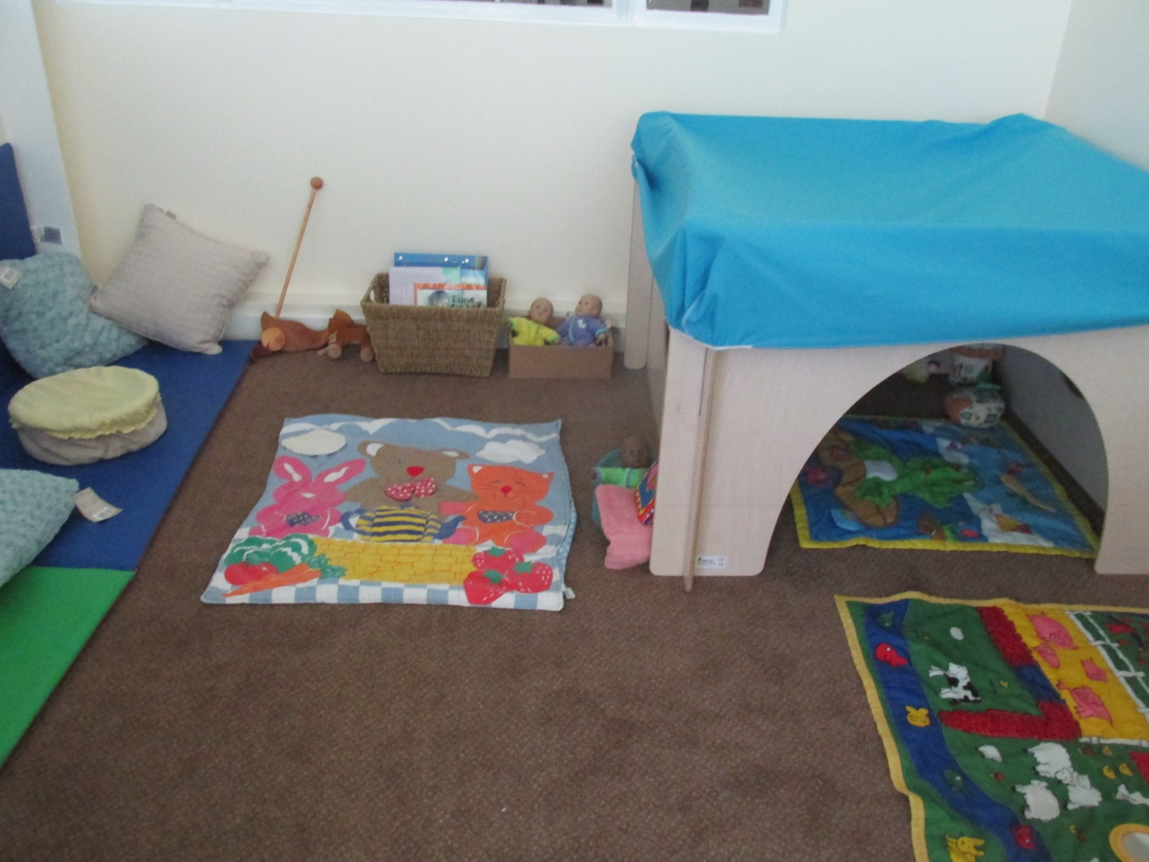

Key person

Each member of staff acts as a Key person with special responsibility for a small number of children, ensuring that the particular needs of every child are recognised through close observation and monitoring of progress. Your key person will liaise closely with you, to provide individual care and attention for your child. Each Key person could have up to 10 children across the day if we get up to full capacity of children per session; the Key person records/comments
A wow moment – evidencing a real learning opportunity an observation showing your child’s engagement in activities indoors and out
Your child demonstrating their communication and language skills etc
All staff will do their best to fill you in on the learning that has been going on when you collect them.

On Arrival

On arrival please follow the footpath to the wooden garden gate at the side of the fence where you can take your child to their door, they will also be collected in this way. If you choose to bring your dog when bringing your child please tie the dog to the grey railings outside the main gate, and away from waiting children due to some children being very nervous around dogs it is also not permitted to bring dogs onto the school premises. If you are running late you will need to go to the main door and ring the buzzer to alert staff to open the door, you may need to wait until they become free to let your child in, please be patient.

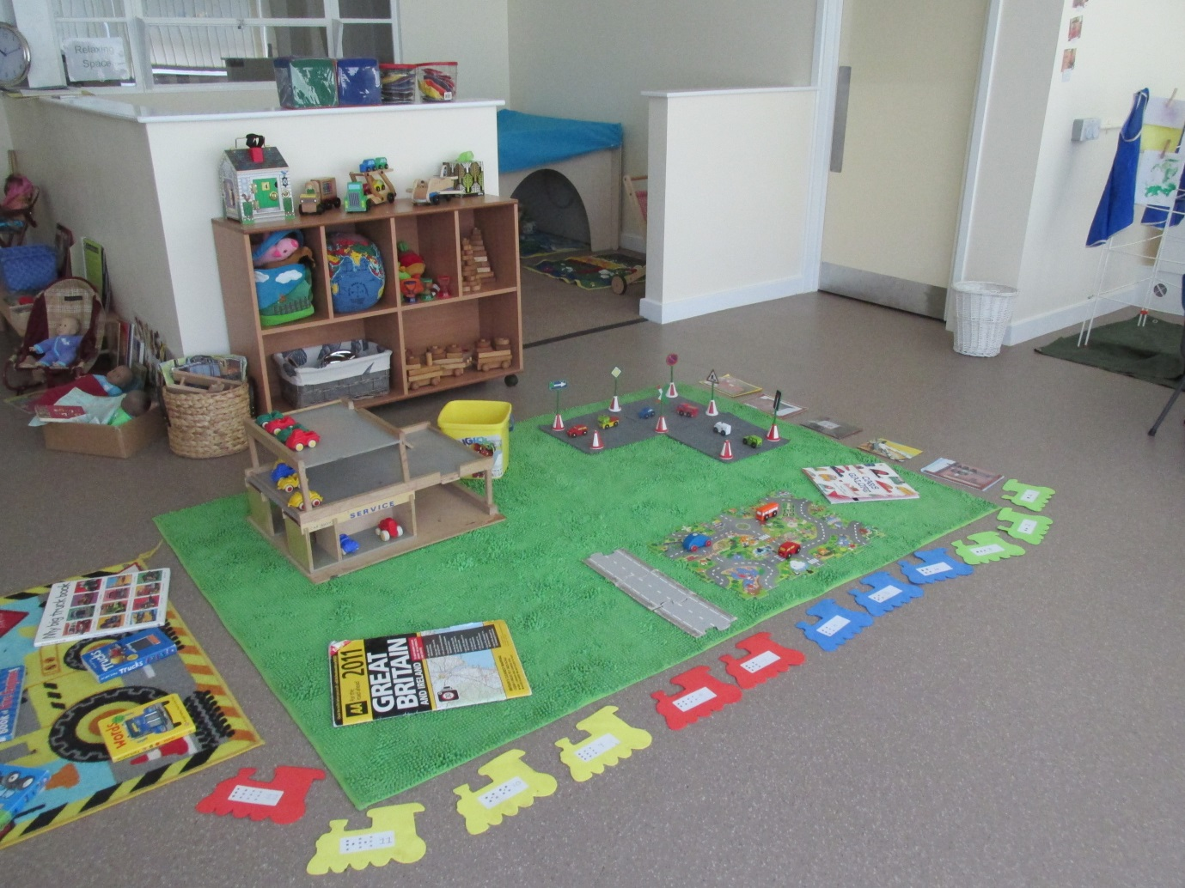

We encourage children to recognise their own name by:

- Looking for a named coat peg and hanging up their own coat
- Place bags on the peg under coat.
- In room –Use Signalong for their name and join in with the welcome song (a way of learning their friend’s names.)

Please note: In accordance with the GDPR 2018, the use of mobile phones and the taking of any photographs in the setting by parents/carers is NOT allowed

Learning Journal

At Little Sparks all children have a Learning Journal/Portfolio that will keep a record of your child’s achievements during his/her time with us at Little Sparks. Parents are welcome to read through this and look through the pictures. We also encourage parents to add any photos, other items or comments to it so that there is a fuller picture of your child from when they start until when they leave; we do usually share the information with the school.

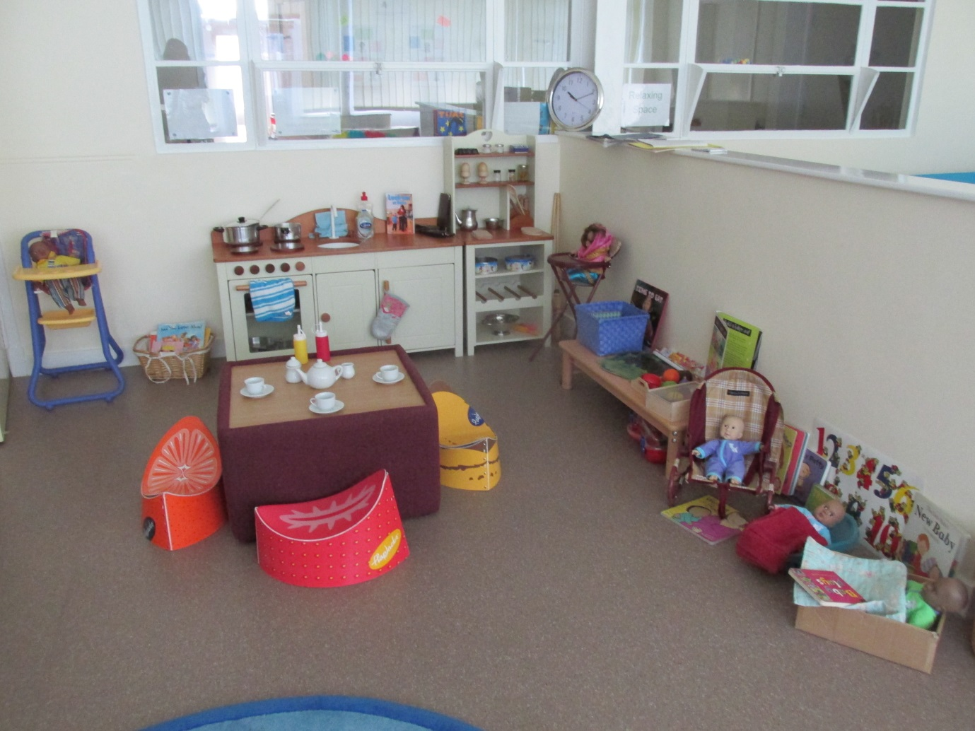

Session plan

We organise our sessions so that children can choose from and work at a range of activities. The children are encouraged to take part in child and adult led activities. Outdoor activities contribute to children’s health and physical development and their knowledge of the world around them.

We operate a free flow system. The doors to the front play area are open so that children may access the outdoor area during the day. They will be supervised while they are in the playground.

The children are able to access IT resources throughout the session and are encouraged to use programmes independently. We have 2 tablets with a range of suitable apps. We have a tape recorder / CD player with headphones that can be used by up to four children at a time, lots of remote controlled toys.

Snack bar

During each session the children are able to have a healthy snack including fruit, salad and vegetables (carrot sticks), bread (toast), milk and water are available. The setting makes snacks and meals a social time at which children and adults eat together. Do tell us about your child’s dietary needs and we will make sure that these are met. There is no need for them to bring drinking bottles from home as drinks are provided regularly in the session and we find that children like to pour out their own drink into their cup.

Healthy Smiles

We ask for parent/carers support when it comes to Birthdays or Celebrations that when you wish to bring something in as part of your celebration that it is not cakes or sweets but a healthier alternative however it is not expected that you have to provide anything. Our birthday celebrations here include:
Wearing the birthday hat
Being sung Happy Birthday too
Receiving a card from friends
Choosing their favourite song to sing
Moving up on our birthday board
If the children would like they can bring their birthday cards in from home to show friends

Outings and visits

From time to time, we arrange short outings to local places of interest including a walk down to the community garden at the back of the park.
During the school year we invite in a variety of visitors including the local Police and Librarian.

Child protection

Little Sparks is committed to promoting the health and welfare of all children. We are required by law to follow procedures laid down by the Norfolk Safeguarding Framework for Early Years. All parents will be required to sign the Registration Form to say they have seen a copy of our Safeguarding and Child Protection Policy it is also on our website alongside other policies. We will email copies to parents if they wish.

Equal opportunities

Little Sparks staff and committee members actively pursue an environment which values and offers equal opportunities for all, whatever their culture, religion or belief, gender, ability, age or class, gender reassignment, marital status, pregnancy and maternity, race, disability or sexual orientation.

Fundraising

From time to time the fundraising that we do enables us to buy more resources for the children or as in the case of Children in Need/Sports relief/Comic relief raising funds for others, we talk to the children about where the money raised goes and why we do it.

2 Year olds Developmental Check

To ensure your child’s development is well supported in the setting we are required to complete a 2 year Developmental Check between the ages of 2 and 3, with yourselves to make sure your child continues to develop and learn.

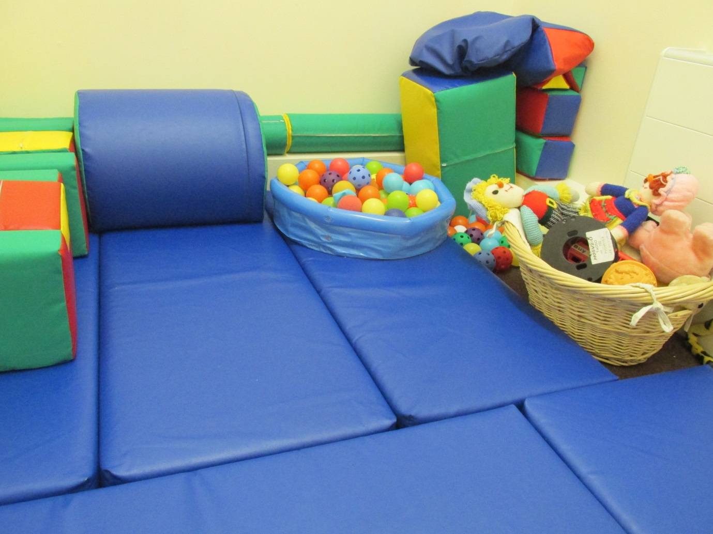

Common Concerns

We understand that at this age range, the children are still learning the fundamentals of personal, social, and emotional development. They are gradually learning how to express themselves positively, and get along well with others of their age.

It’s not uncommon for children to become upset, have tantrums, bite and have disagreements with each other when difficulties in their communications arise. This may result in parental concerns. Please feel free to discuss these worries with a staff member. There are many strategies that may be useful to use.

