Little Sparks
Preschool

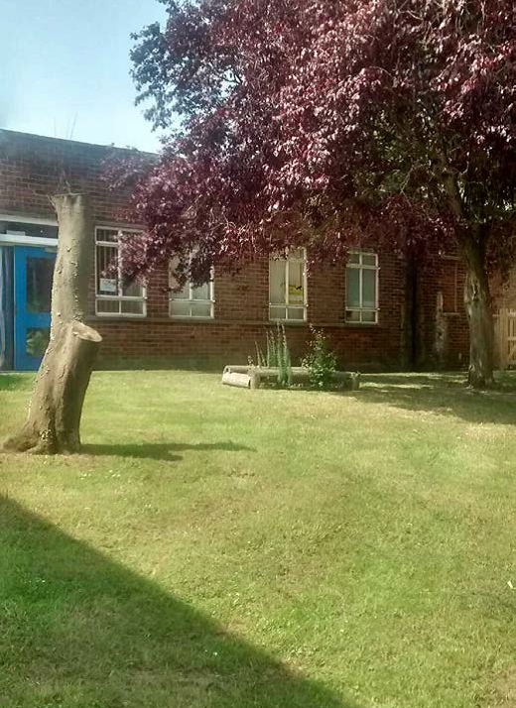

Little Sparks Preschool
Knowland Grove
Norwich
NR5 8YB
Telephone: 01603 740677
Mobile: 07592 525542

Registered Charity Number: 1079011
Introduction

Little Sparks Preschool is a charitable organisation. We welcome the close involvement of parents and carers and run by a voluntary committee of parents. We are registered with OFSTED to provide early years education for 24 children aged 3 and 4 years old and 10 children aged 2 years old per session.

Aims

The aims of the preschool are to:

- Advance the education of children below compulsory school age in Norwich
- Provide a safe place for children to play together and socialise
- For children to experience new activities and have a go
- Support the children’s growing independence in a safe, nurturing and learning environment.

What we do

We provide a learning environment that is exciting and stimulating, indoors and out.

We allocate every child a ‘key person’. The key person will work closely with your child and you to support your child during their time at Little Sparks.

We ensure all the children have equal access to a diverse and rich curriculum.

We follow each child’s interests and extend their play and learning.

How we are managed

Little Sparks is a registered charity with a committee of parents, carers and representatives of the local community who manage the group.

Committee meetings are held each term and all parents and carers of children who attend the Little Sparks are eligible to join the committee. The committee is elected annually at an Annual General Meeting held in the autumn.

All committee members require DBS checks.

Our committee officers are:

Chairperson Karen Rowley
Secretary Jackie Walker
Treasurer Karen Chapman

Our Staff

All childcare is provided by registered, professionals who are fully trained in looking after children and have been DBS checked.
.

Position | Name | Area of responsibility
Childcare Manager | Jackie Walker | DSL, ENCO Prevent Duty
Deputy Childcare Manager | Donna Reynolds | DSL, Health and Safety, Behaviour Management, Food Safety
Childcare Practitioner | Tammy Jay | DSL SENCO
Childcare Practitioner  Childcare Practitioner  Volunteer Practitioner | Laura Kelly  Chloe-Jane Herring  Karen Chapman | CP E-Safety First Aid Fire Safety  CP

Opening Times

Little Sparks is open Monday to Friday for 3 and 4 year olds. We are open school term times.

Monday 8:50 – 11:50 12:20 – 3:20
Tuesday 8:50 – 11:50 12:20 – 3:20
Wednesday 8:50 – 11:50 12:20 – 3:20
Thursday 8:50 – 11:50 12:20 – 3:20
Friday 8:50 – 11:50 12:20 – 3:20

Children move up from 2 year group within the setting as follows:
As a space becomes available, age appropriate
When they are ready, age/stage is taken into consideration and their individual needs can be supported for a smooth transition
Staff will discuss with parents/carers your child’s transition

New children going straight into the three year room may start term after their third birthday.

Please make sure that you arrive promptly so that all the children can start the session together on time and that you are waiting for them at the end of the session.
If you wish to collect a child early please chat to key person as when new children are starting they can get very upset with children coming and going at different times.

Term dates

Autumn Term
3rd September to 19th December 2025
Half term is 27th October to 31st of October 2025

Spring Term
6th January to 27th March 2026
Half term is 16th February to 20th February 2026

Summer Term
14th April to 17th July 2026
Half term is 25th May to 29th May 2026- Bank Holiday 4th May 2026
We follow Norfolk County Council School Term Dates

Costs

Sessions are FREE for all children the term after their third birthday. The Government funds 15 hours of early year’s education per week during school term time and in certain circumstances you may be able to claim 30 hours a week. However, please make sure your children attend their allocated sessions – prolonged absence could mean funding being stopped, it also helps with the settling in and continuity of care for your child.
We run our 30 hours from 8.50am - 2.50pm 5 days a week, as our session in the afternoons finishes at 3.20pm you have the option of paying for an extra 30 minutes daily at the end at a cost of £2.25 per day or £11.25 for the week. It may possible to pay for extra sessions at £13.50 per session, payable even if absent.

Fees for the extra sessions/ 30 minutes can be paid monthly directly into the bank; we will invoice you with bank details included.

Clothing

Please put children in clothing that you don’t mind getting messy. We encourage children to use the toilet independently so please dress them in clothing which supports this, ensure clothing is easy for children to pull down or undo when requiring the toilet (jogging bottoms are easier than trousers with tight or awkward belts and fastenings).

Please bring a spare set of clothes, nappies, wipes, nappy sacks for your child which can be kept in a named bag at preschool, in case of any little accidents.

Please name items to make it easier for staff to know who it belongs too.

Children use a variety of equipment inside and outside, so please ensure that your child is appropriately dressed to allow them to be safe. Appropriate shoes and clothes for playing and no long dresses crop-tops, or strappy sun dresses are to be worn.

On sunny days we provide a sun hat for your child to wear, please make sure their shoulders are covered. On wet days or when the ground is muddy please provide wellies for your child to put on, we provide outdoor wear. We support the children playing indoors and outdoors and we are not put off by the change of weather, sometimes parents worry that their child has a runny nose and they would rather they stay indoors, however perhaps on these days you might need to consider keeping them off if they are to poorly.

Jewellery

To reduce the risk of accidents please limit the jewellery your child wears. No loose jewellery (necklaces, drop earrings) should be worn but stud earrings are acceptable.

If using hair bobbles and hair clips, please be aware children may take them off and lose them, staff are not responsible for hair clips, earrings or any item of jewellery if they are lost or broken during a session, precious items or expensive hair bobbles need to be kept for best.

Toys / Comforters

Bringing something from home, staff cannot accept responsibility if they get lost or broken, please limit the amount to one small item. This must fit in their bag as we have limited coat peg space. Items left outside must not block the front door safety exits and are left at your own risk.

Home Visits

We will arrange a time for a home visit where time allows
Two staff members will pop in to meet you and your child. This also provides you with an opportunity to tell us about your child ask questions and discuss any concerns you may have, visits usually last around 45 minutes.

How we operate

We follow the Early Years Foundation Stage.

Through observing your child, encouraging play and having fun we seek to extend and build your child’s knowledge and understanding. The Areas of Learning and Development consist of 3 Prime areas which are Personal, Social and Emotional Development, Physical Development and Communication and Language. There are 4 Specific Areas which are Literacy, Mathematics, Understanding the World and Expressive Arts and Design.
We value parent/carers contributions and recognise the value that families play in the education of their child.
We provide an environment in which all children are supported to reach their full potential. We follow the Department of Education and Skills Special Educational Needs Code of Practice 2014. We work in partnership with parents/carers and a range of agencies.

Settling in

Some children do not settle in quite as easily as others and may need a parent or carer to stay with them for a while to start with. Please feel free to do this and in time your child will be happy to stay on their own.

Key person

Each member of staff acts as a Key person with special responsibility for a small number of children, ensuring that the particular needs of every child is recognised through close observation and monitoring of progress. Your Key person will liaise closely with you, to provide individual care and attention for your child. They will also keep your child’s Learning Journey/portfolio. Each Key person could have up to 16 children across their morning and afternoon sessions if we get up to full capacity of 24 children per session; the Key person only comments on:
A wow moment – evidencing a real learning opportunity
An observation showing your child’s engagement in activities indoors and out
Your child demonstrating their communication and language skills etc
All staff aim to update you regularly and will often fill you in on the learning that has been going on that day when you collect your child.

On Arrival

On arrival please follow the footpath to the wooden gate at the side of the fence you will then collect from the main door at the end of the session. If you choose to bring your dog when bringing your child please tie the dog to the grey railings outside the main gate, and away from waiting children due to some children being very nervous around dogs it is also not permitted to bring dogs onto the school premises. If running late please use buzzer to alert staff to open the door, you may need to wait until they become available, please be patient we will get there.

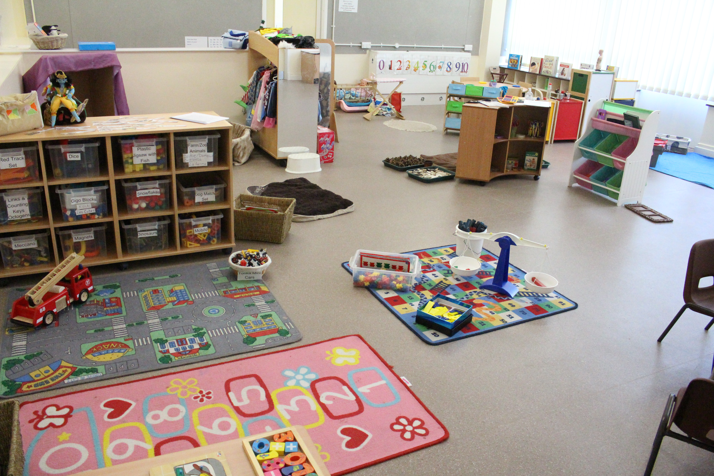

When entering the setting

We encourage children to recognise their own name by:
- Looking for their named coat peg and hanging up their coat
- Place bags on the peg under coat and hang lunch boxes up

Morning Routine
Registration and saying Good Morning/Afternoon using Sign along
- Go and wash their hands
- Clean teeth

Please note: In accordance with the GDPR 2018, the use of mobile phones and the taking of any photographs in the setting by parents/carers is NOT allowed

Learning Journal

All children have a Learning Journal/Portfolio; this will keep a record of your child’s achievements during his/her time with us at Little Sparks. Parents/Carers are welcome to look through this, we also encourage you to add any photos, other items or comments to it providing us with a fuller picture of your child from when they start until when they leave. We do usually share the information with the school.

Session plan

We organise our sessions so that children can choose from and work at a range of activities. The children are encouraged to take part in child and adult led activities. Outdoor activities contribute to children’s health and physical development and their knowledge of the world around them.
We operate a free flow system. The doors to the front play area are open so that children may access the outdoor area during the day. They will be supervised while they are in our outdoor spaces.
The children are able to access IT resources throughout the session and are encouraged to use them independently. We have a tablet with a range of suitable apps. We have Tuff cams for the children to use under adult supervision, a tape recorder / CD player with headphones that can be used by up to six children at a time, lots of remote controlled toys and children also like using our mini microscopes.
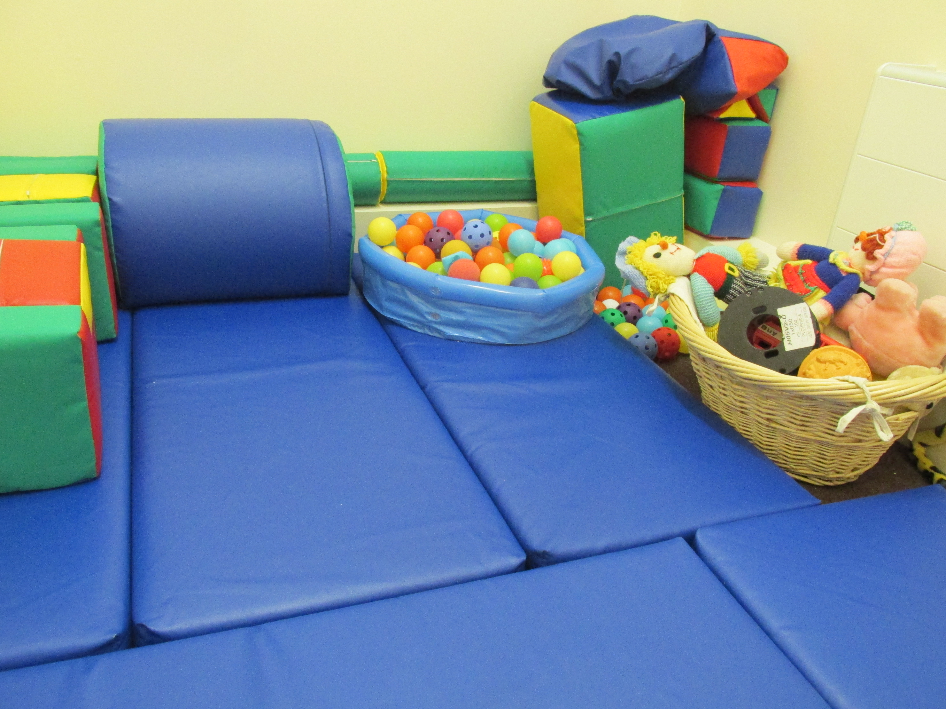
Lunch Times

For children attending 30 hours a week

We are following the Healthy Norfolk Schools guidelines and the Healthy Smiles Campaign and would like to remind you to look at what you put in your child’s packed lunch. The following are some very useful tips.

- No sugary drinks
- No chocolate biscuits or sweets
- One or two sandwiches/wrap/ roll (often lots of sandwiches are just too much)
- One yoghurt
- Fresh fruit/salad/carrot sticks (aiming for five a day)
An ideas sheet for packed lunches is available
Please provide an appropriate named lunch box with ice pack to ensure contents stay cool and a spoon if required.
Please be aware that some foods can be a choking hazard, i.e. cut grapes length ways and quartered. Also avoid nuts in any food items brought in from home as we may not always be aware of an undiagnosed nut allergy.

Snack bar

During each session the children are able to have a healthy snack including fruit, salad, and vegetables (carrot sticks), bread (toast), milk and water are available. The setting makes snacks and meals a social time at which children and adults eat together. Do tell us about your child’s dietary needs and we will make sure that these are met. There is no need for them to bring drinking bottles from home as drinks are provided regularly in the session and we find that children like to pour out their own drink into their cup.

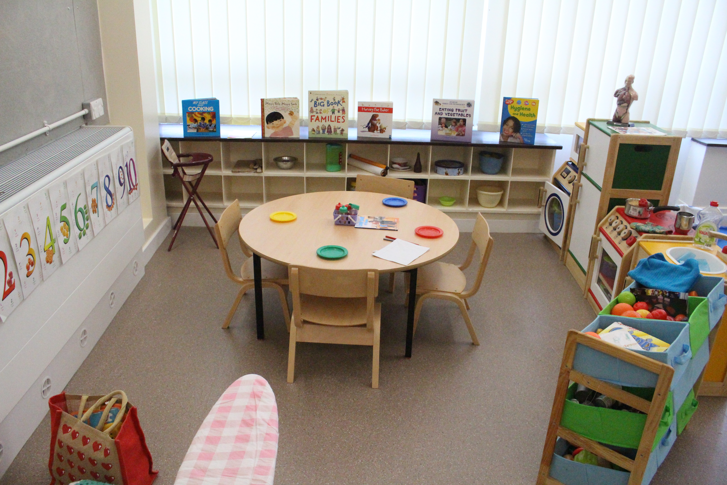

Healthy Smiles Programme

We follow the above programme and set aside time each day for the children to clean their teeth, we also have some handy tips and advice for families all about dental hygiene.

Outings and visits

From time to time we arrange shorter outings to local places of interest, such as Norwich castle or a riverside walk. During the school year we invite in a variety of visitors for example the Fire brigade, Police, Librarian etc. to support the children’s learning.

Child protection

Little Sparks is committed to promoting the health and welfare of all children; we are required by law to follow procedures laid down by the Norfolk Safeguarding Framework for Early Years. All parents will be required to sign the Registration Form to say they have seen a copy of our Safeguarding and Child Protection Policy, they are on our website. We will email copies to parents if they wish.

Equal opportunities

Little Sparks staff and committee members actively pursue an environment which values and offers equal opportunities for all, whatever their culture, religion or belief, gender, ability, age or class, gender reassignment, marital status, pregnancy and maternity, race, disability or sexual orientation.

Fundraising

From time to time the fundraising that we do enables us to buy more resources for the children or as in the case of Children in Need/Sports relief/Comic relief raising funds for others, we talk to the children about where the money raised goes and why we do it.

Holidays and days off

A long amount of time away from the routine of the preschool can be confusing for young children.
It is very important in your child’s last term here before moving on to Primary School that they attend regularly, aiding good preparation for the longer school days. Lots of transition work is done during this time to make it easier for your child. To ensure a child’s safety we will contact you if you have not given us a reason for your child’s absence.

Common Concerns

We understand that at this age range, the children are still learning the fundamentals of personal, social, and emotional feelings. They are gradually learning how to express themselves positively, and get along well with others of their age.

It is not uncommon for children to become upset, have tantrums, bite and have disagreements with each other when difficulties in their communications arise. This may result in parental concerns. Please feel free to discuss these worries with a staff member. There are many strategies that may be useful to try.

Pupil Premium

For those children who we receive money under this entitlement we spend this on appropriate resources to enhance your child’s learning.

Healthy Teeth Awards

We have signed up to this brilliant scheme supporting children to clean their teeth once a day in the setting, we are encouraging them to understand the importance of taking care of their own teeth and making tooth friendly choices when it comes to what they eat and drink.
We encourage Parents/Carers to register with a Dentist although we appreciate how difficult this has been lately.
Children enjoy a range of activities around the Healthy Smiles Programme these include:
Looking at books about our teeth
Investigating the Playdough Dentist Kit
Giant teeth and toothbrush cleaning
Food tasting and healthy choices
Knowing where their fruit and vegetables come from.

We have a duty of care to all children in our setting and will support you finding a Dental Practitioner who may advise you, if we have concerns regarding the children’s teeth especially when we feel it impacts on their health and wellbeing.

We ask for parent/carers support when it comes to Birthdays or Celebrations that when you wish to bring something in as part of your celebration that it is not cakes or sweets but a healthier alternative however it is not expected that you have to provide anything. Our birthday celebrations here include:
Wearing the birthday hat
Being sung Happy Birthday too
Receiving a card from friends
Choosing their favourite song to sing
Moving up on our birthday board
If the children would like they can bring their birthday cards in from home to show friends.

