Little Sparks PreschooL

Newsletter October 2025


Welcome back
Toilet Training
The week off is a good time to encourage toilet training especially for children in butterfly room who will be going to primary school next September
The children have settled well and our having fun. For their learning journals send over some family photos including pets as they like looking at their photos

Half Term
We break up for October half term in Butterfly room next Friday

Valley Primary Academy will be off for two weeks – we will still be in the week beginning 2/11/25

Caterpillar room will be checking whose in with parents/carers

Time to choose
You have until January to choose a Primary school for September 2026
Schools are having stay and play sessions Valleys is next week



Debutots
Marie joins us once a week on a Monday for a story session encouraging the children to help tell stories and act them out, lots of fun had by all! If you scan the QR code on the hand out you were given you can have access to activities to do with your child at home


Healthy Smiles

We will be continuing with our Healthy Smiles Programme supporting your children with teeth cleaning and learning to take care of them making tooth friendly choices to prevent tooth decay especially when it is hard to find a dentis
Lovely Learning

Children are learning to play together, share and take turns.


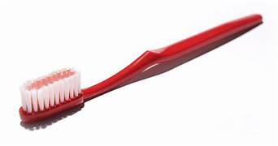
Home – School fun
Encourage children’s growing confidence to do more for themselves including
Dressing
Using cutlery
These re good skills to have

Look at the changes
Autumn brings, all the wonderful colours. Collect natural materials for children to show.
Enjoy Autumn walks listening for the birds
Visit the library

By 3 children should know their full name and address.
Send over on Whatsapp a picture of your front door (house) to add to their learning journals supporting them learning their address.

As the weather gets colder, put extra layers on children, we can always remove a cardigan etc if they get too hot

Label clothes/shoes

Provide wellies please for wet and muddy puddles play

Jewelry
No dangly earrings or hoops/ necklaces as there is a risk of them being pulled out or a choke hazard

