Toilet Training Tips
Set goals to help your child
Your aim is you and your child working towards them being able to use the toilet without help
Set time aside for you to be able to accomplish this together – be prepared for accidents
Need to feel relaxed in the toilet environment
Have a plan:
Use a potty
Sit on the toilet
Have some toys in the bathroom
Story books about using the toilet
Ensure a good seating position using a step and inset seat for the toilet if this helps
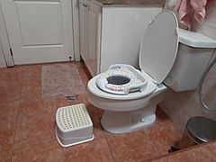
Toileting Plan
For to be happy and comfortable sitting on the toilet regularly
Learning goals:
To be independent pulling down/up clothes
Using toilet paper to wipe
Washing and drying hands
To sit on the toilet at the same time each day
Use a timer – set it for five minutes and a box of toys for distraction (small toys, bubbles, singing songs)
To encourage a bowel movement: blow bubbles, raspberries on back of their hand or blow a toy trumpet
Offer a drink ten to fifteen minutes before sitting on the toilet
Turn on a tap

Times to sit on
First thing in the morning
Mid-morning
Thirty minutes after finishing lunch
Mid afternoon
Twenty minutes after finishing tea
Before bed

