Why toilet train?
It is a skill that children need to develop independence, self-esteem and confidence and it is expected that by the time they start Primary school that every child should be able to go to the toilet independently.
Who is responsible?
It is up to Parents/Carers to support their children learning this skill
Preschool staff will assist but it is your responsibility to actively encourage your child reaching this milestone.
Please access the ERIC and Just One Norfolk website these will have more information and resources regarding potty/toilet training



How do you know if your child is ready?
Showing an interest in going through to the bathroom
Child takes their nappy off
Tells you they are doing a wee
Tell-tale signs to look for:
Noticed your child has started to wee/poo
Hides away to have a poo
Fidgeting or giving a little shiver
Holding on to the last minute or too long
Reluctance to be changed as they have already done the deed
If you notice your child can stay dry for up to an hour
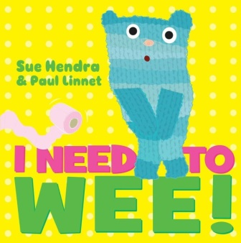
Problems with toilet training
If your child has Special Educational Needs it does not mean that they will not achieve this stage however your child may need extra support and time to accomplish this
You can always contact your Health Visitor Just One Number 0300 300 0123 for more information
Or go online and look at ERIC’S Guide to Potty Training it has lots of helpful handy hints/toilet training with additional needs
Ask family to support – grandparents have been here, done that, got the t-shirt
Underlying reason: Talk to Health Visitor or Doctor in case it is something medical that needs further investigation
This leaflet has been put together with Little Sparks staff and advice from 0-19 Norfolk Healthy Child Programme/Health Visitors/ERIC website

